Wireframe:
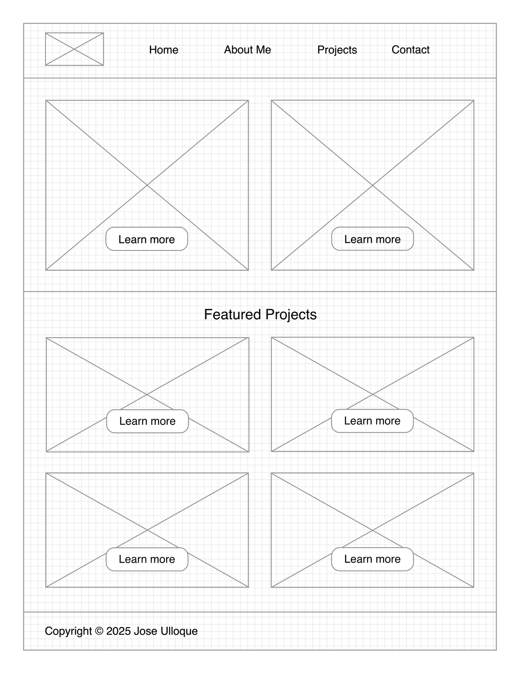

Logo:
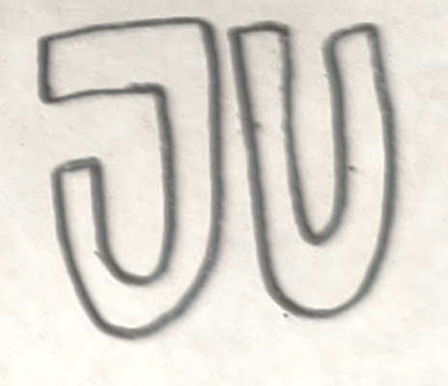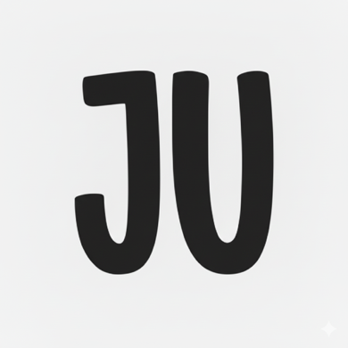
The logo is still a work in progress. J and U are my initials. The first image is a sketch I made, and the second Image is an AI enhancement of the sketch. The final logo will be similar.

Color Scheme:
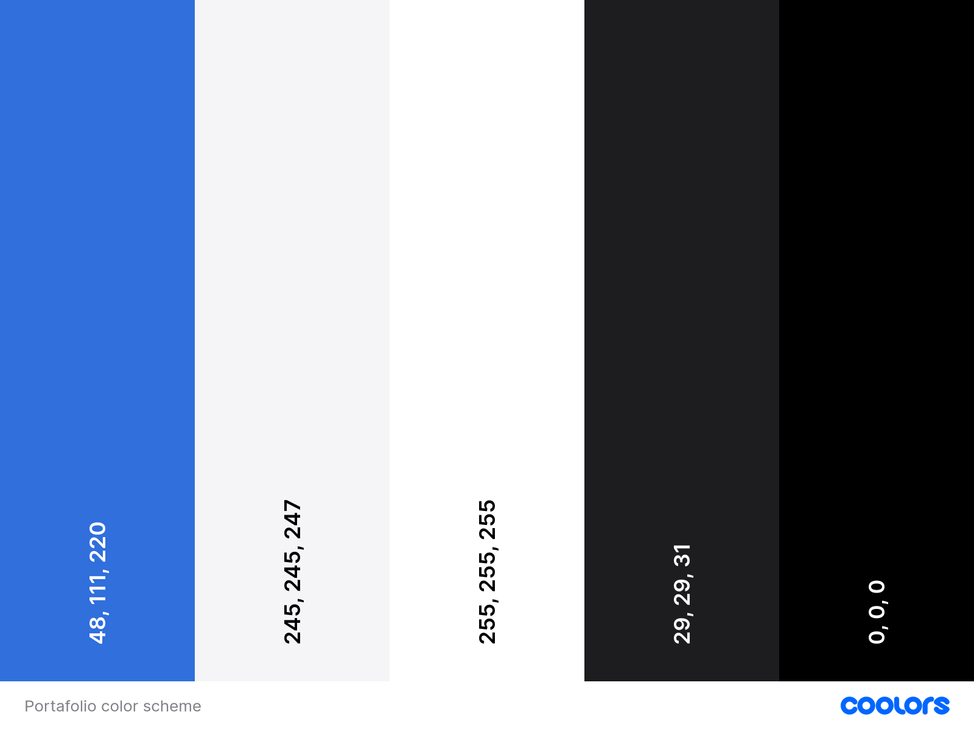

Font choices:
I will manly and almost exclusively use the font “Inter” designed by Ramus Andersson. This font is available in Google Fonts. My decision to use only one font is because I am looking forward to making a portfolio that looks modern, minimalist, and clean. What I will do is that I will play with how bold the font is. Here is an example:
H1
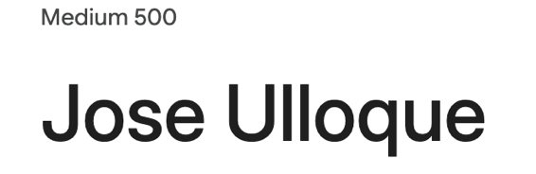

H2
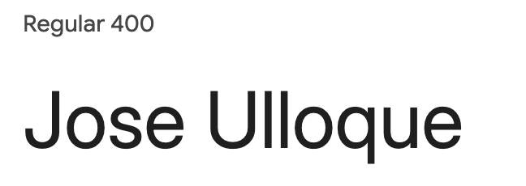

Paragraph
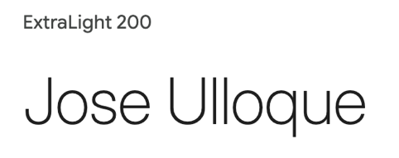

In case that the font does not load, an alternative font could be Arial or Helvetica.

